**Name : Chandana Ramesh Galgali Roll Number : 16010422234 Batch : B-4**

**Tutorial - 5**

**______________________________________________________________________________**

**Code:**

**<!-- HTML FILE -->**

**<!DOCTYPE html>**

**<html lang="en">**

**<head>**

**<meta charset="UTF-8">**

**<meta name="viewport" content="width=device-width, initial-scale=1.0">**

**<title>Perfume Emporium</title>**

**<link rel="stylesheet" href="styles.css">**

**</head>**

**<body>**

**<header>**

**<h1>Perfume Emporium</h1>**

**<nav>**

**<ul>**

**<li><a href="#samepage">Home</a></li>**

**<li><a href="#">Shop</a></li>**

**<li><a href="#">About Us</a></li>**

**<li><a href="#samepage">Contact</a></li>**

**</ul>**

**</nav>**

**</header>**

**<section class="main-section">**

**<h2>Featured Perfumes</h2>**

**<div class="perfume">**

**<img src="perfume1.jpg" alt="Perfume 1">**

**<h3>L'Instant Magic</h3>**

**<p>L'Instant Magic by Guerlain is a captivating fragrance that embodies elegance and femininity. It opens with fresh and citrusy notes of bergamot and lemon, leading into a delicate floral heart of jasmine and rose. The base notes of white musk and cedarwood add depth and warmth to this enchanting scent, leaving a trail of magic wherever you go.</p>**

**</div>**

**<div class="perfume">**

**<img src="perfume2.jpg" alt="Perfume 2">**

**<h3>Miss Dior</h3>**

**<p>Miss Dior by Christian Dior is a timeless and iconic fragrance that exudes charm and sophistication. This classic scent features top notes of Italian mandarin and Egyptian jasmine, giving it a fresh and floral opening. The heart of the fragrance is a bouquet of rose and patchouli, creating a romantic and elegant allure. With its musky and woody base notes, Miss Dior leaves a lasting impression, making it the perfect choice for any occasion.</p>**

**</div>**

**</section>**

**<footer>**

**<p>&copy; 2024 Perfume Emporium. All rights reserved.</p>**

**</footer>**

**</body>**

**</html>**

**/* CSS FILE */**

**body {**

**font-family: Arial, sans-serif;**

**margin: 0;**

**padding: 0;**

**}**

**header {**

**background-color: #f0f0f0;**

**padding: 20px;**

**box-shadow: 0 2px 4px rgba(0, 0, 0, 0.1);**

**}**

**header h1 {**

**margin: 0;**

**}**

**nav ul {**

**list-style-type: none;**

**margin: 0;**

**padding: 0;**

**}**

**nav ul li {**

**display: inline;**

**margin-right: 20px;**

**}**

**nav ul li a {**

**text-decoration: none;**

**color: #333;**

**}**

**nav ul li a:hover {**

**color: #5a3975;**

**}**

**.main-section {**

**padding: 20px;**

**display: flex;**

**flex-direction: column;**

**align-items: center;**

**text-align: center;**

**}**

**.perfume {**

**max-width: 60%;**

**margin-bottom: 20px;**

**padding: 20px;**

**background-color: #919191;**

**border-radius: 15px;**

**box-shadow: 0 2px 4px rgba(0, 0, 0, 0.1);**

**transition: transform 0.3s ease;**

**}**

**.perfume:hover {**

**transform: translateY(-10px);**

**}**

**.perfume img {**

**width: 300px;**

**height: 350px;**

**max-width: 100%;**

**border-radius: 15px;**

**}**

**footer {**

**background-color: #333;**

**color: #fff;**

**text-align: center;**

**padding: 20px;**

**}**

**______________________________________________________________________________**

**Output:**

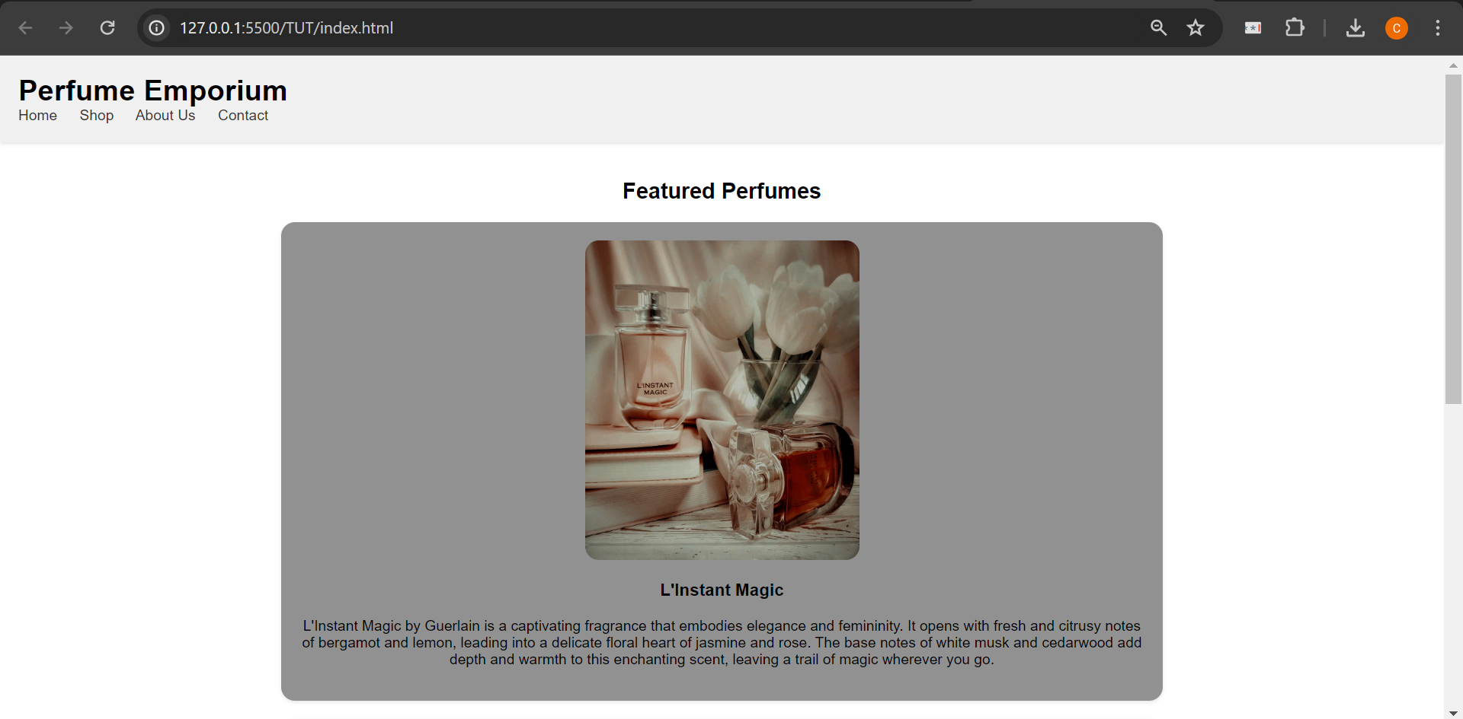

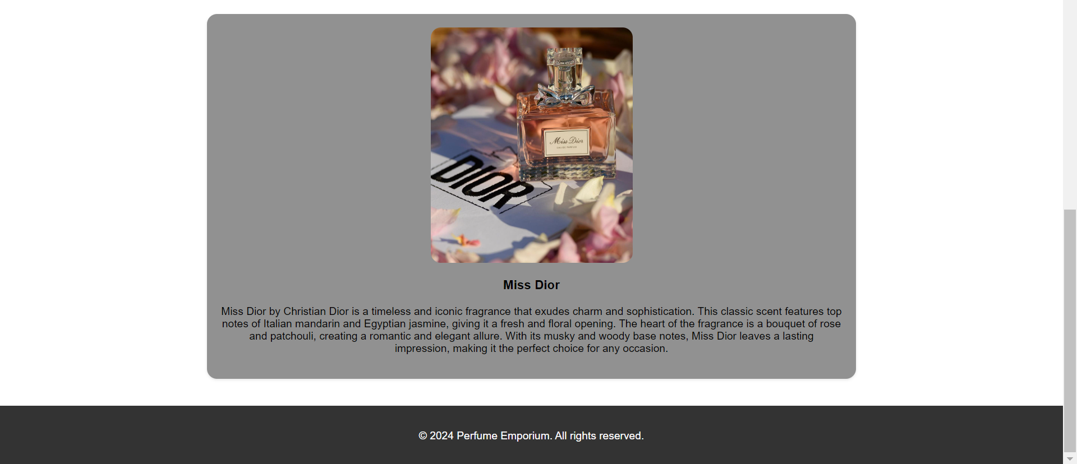

**______________________________________________________________________________**

**Outcomes:** Create Web pages using HTML 5 and CSS.

**______________________________________________________________________________**

**______________________________________________________________________________**

**Conclusion: (Conclusion to be based on the outcomes achieved)**

The experiment demonstrated the effectiveness of using HTML5 and CSS3 to design and style a web page. By incorporating a range of features such as backgrounds, gradients, transitions, and pseudo-elements, the resulting web page achieved enhanced visual appeal, improved user experience, stylistic consistency, and a modern, professional look. These outcomes highlight the significance of leveraging the capabilities of HTML5 and CSS3 to create compelling and functional web experiences.

**______________________________________________________________________________**